July 22, 2022

Ann M. Graham, Executive Director Reentry Association of WNY
71 Olde Tavern Circle
Rochester, New York 14612

Dear Ann,
Spiritus Christi Prison Outreach fully supports the Reentry Association of WNY's proposal to create a Reentry Continuum of Care Pilot Program to provide a single point-of­ entry for the formerly incarcerated who are returning to our community.
Monroe County is known for its vast human resources. Yet, access to these resources for a person released from incarceration are extremely difficult to access. The formerly incarcerated are not provided the guidance they need to connect with services designed to address their unique issues. A single point-of-entry for the formerly incarcerated where they can be assessed for needs and connected to appropriate service providers would remedy this problem.
The reentry service community needs an organization that can advocate for additional funding to improve services and develop minimum standards for the provision of reentry services. The Reentry Association of WNY is uniquely positioned to provide those services given your expertise and years of experience.
Spiritus Christi fully supports the efforts of Reentry Association of WNY's proposal to create a Reentry Continuum of Care Pilot Program we look forward to offering our transitional housing programs (Jennifer House and Nielsen House) to referrals that meet our organization criteria.

Sincerely,
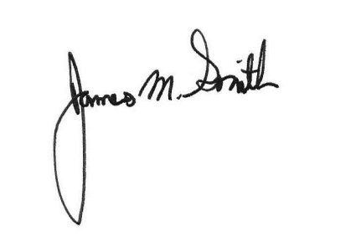

Jim Smith, LMSW, CASAC
Executive Director

